An Historical Overview
In 1954, a group of parents desiring a meaningful religious education for their children which would encourage them to foster human values, question orthodoxy, use democratic methods, and practice racial, religious and social tolerance, founded a small Unitarian Fellowship. In 1962, the Fellowship became a Unitarian Church. The following year, the congregation called its first minister, Robert Senghas, and bought a 9.3- acre site to build a church. In 1967, 2.6 acres were sold to help finance building the new church. The current grounds encompass 6.6 acres.
The original buildings dedicated in 1968 included a Meetinghouse and the “entry building” (kitchen, bathrooms and Senghas Room). An open patio between the buildings became the floor of the “Great Hall” when the walls and ceiling were added in 1975.
Meanwhile, Viola Hildebrand designed the grounds. In spring of 1969, Viola rode in the bulldozer as the grounds were sculpted for landscaping and flood control. The original tree seedlings and shrubs painstakingly watered through many summers are now fully mature.
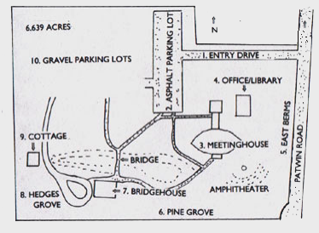
In the early 70s, the congregation raised additional funds to build the “Bridgehouse.”
In May of ’89, the membership authorized a construction fund of $240,000. In 1991, the Library/Administration building was completed with a major volunteer effort by the congregation. Most recently, another capital campaign and major volunteer effort created the social hall and kitchen.
Over the years, various building committees have kept the buildings in good shape, while the grounds committees maintained the grounds and added new landscaping features for the enjoyment of all – including the abundance of wildlife who consider the grounds their home. The addition of a water feature provided a permanent water source and qualified UUCD as a certified National Wildlife Federation Wildlife Habitat.



Our Mission is to welcome each and all, cultivating the spirit, serving others in our quest for justice.

Rev. Elizabeth Banks, Senior Minister

Unitarian Universalist Church of Davis
Location: 27074 Patwin Road, Davis, CA
Email: office@uusofdavis.org
Website: www.uusofdavis.org
Phone: 530.753.2581
Mail Address: 27074 Patwin Road
Davis, CA 95616

Ground’s Map: Key to Areas Described

Our
Unitarian
Universalist Church of Davis Park

An Overview

And

Self-Guided Tour
Of The
Buildings And Grounds

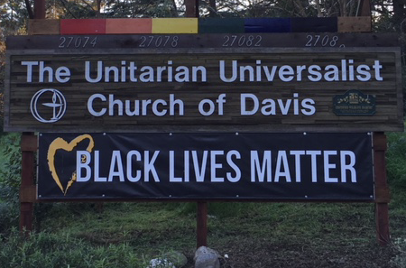

Welcome to the Unitarian Universalist
Church of Davis, a Green Sanctuary
Church. We are grateful for our church
founders, our generous members, and our
devoted landscapers and gardeners who
wisely planted and have cared for drought-
tolerant trees that now provide us such
coolness, beauty, solace, and opportunity for
quiet reflection.
1. Driveway into the Grounds
At the entrance, the church sign is set off by crepe myrtles and drought-tolerant plantings designed by Gail Jankowski. Deodar cedars, ceanothus, Canary Island pines, a Nichol’s willow-leafed eucalyptus (from New South Wales, Australia), carobs, and holly-leafed oaks line the north side of the drive. Deodar cedars, holly-leafed oaks and matilija poppies line the south side.

2. Asphalt Parking Lot Area
In the spring, a crab apple on the west edge of the parking lot makes heavenly clouds of blossoms. The Grounds Committee planted many Canary Island pines and Pittosporum shrubs to screen the parking lot and periphery.
A bench dedicated to Kerry Joyce Datel sits under a sunburst locust south of the parking lot, and several Sycamore trees grow south of the sanctuary while Chinese pistache trees on the north side provide glorious autumnal foliage. North of the Church is Dora’s Garden, a memorial to Dora Hunt who cared for the grounds for many years. The carved post at the entrance comes from our sister church in Duroc, Transylvania. In the last 5 years the church grounds have been replanted to be more drought tolerant.

3. Meetinghouse/ Sanctuary
The original church buildings consisted of the “Meetinghouse,” now called the “Sanctuary”, and an “Entry Building,” The two buildings were designed by noted architect Walter Thomas Brooks of Berkeley in Craftsman style in 1968. In 2012, the Entry building and space between were replaced with the present Social Hall, bathrooms, full kitchen, and a small meeting room (the “Senghas” Room, named for the first minister). It was funded by a capital campaign and much labor of love.
4. Library-Office and Patio Area
The Library-Office building, completed in 1991, was built by many volunteers and a contractor. A cork oak, a Chinese pistache, and a ginkgo shade the Kleiber-Stout Patio.
The deodar cedars planted east of the Library screen the pump and water tanks. In 1986, Don and Mary Lockhart donated the Lockhart Family Memorial Redwood Grove on the east berm. Gale Sosnick designed the Memorial Wall in the spring of 2000, and it was recently expanded with new posts for additional memorial plaques among the crepe myrtles.

5. East Berms and Amphitheater
Initially, the property was a flat field. In order to make the area more attractive and less prone to flooding, the grounds committee had the land around the newly constructed church graded.
Originally, the berms were planted with holly-leafed oaks and shrubs, but now almonds, redbuds, and black walnuts have taken root as well.
The Amphitheater was part of the original grading and the fire circle was added in the 90s. Western ground squirrels, jackrabbits, and brush rabbits enjoy the area.
In 1983, the Hansen family dedicated the Ellen Hansen memorial bench and meditation area south of the Sanctuary garden. In 1986, Jim and Susan Saum contributed a memorial circle of flowering plums.

6. Pine Grove
The Grove of Canary Island pines can be seen from the Sanctuary windows. The Grove has been used for Sunday morning services, weddings and memorial services. To the east, a memorial bench dedicated to Dick Grau invites the visitor to a time of quiet meditation. See the insert on the labyrinth.
7. Bridgehouse and Swale
In 1971, Gale Sosnick adapted a Streng Brothers house design to provide space for religious education classes. The house was built for $20,000, with an additional room added in 1988. Since 1984, the building has been rented to Redbud Montessori School. The church uses it on weekends.
Big leaf maples, some redbuds and a huge fruitless mulberry shade the building.
On the north along the swale, hybrid flannel bushes, California buckeyes, and silk trees flourish. Austin Armer, who raised many of the plants for the grounds, built the bridge across the swale. Roman Gankin brought many of the trees, such as the Canary Island pines, from the UCDArboretum. He even raised many of the now mature oak trees from the Arboretum acorn collection!

8. Hedges Grove Picnic Area
Ted Hedges kept the original trees planted in this corner of the grounds watered. After his death, the church decided to create a picnic area under the grove. The lawn, picnic tables, shrubs and some new trees, including oaks, pistachios, Siberian elms, and wingnut trees were added in 1984-85.

9. Cottage
The Cottage (Roman’s old office) was purchased from UCD and moved to the Church property in 1970. It has served as a craft house, a caretaker’s home, and a meeting space. In 2005, it was brought up to code and made handicap accessible for meetings and classroom use. An Afghan pine is planted southwest of the cottage.

10. Gravel Parking Areas
Coast live oaks and interior live oaks shade the parking lots, plus an Afghan poplar on the s. side of the south parking lot. Visitors hear robins, scrub jays, mockingbirds, and mourning doves, and may glimpse a gopher snake or a western fence lizard.

